As of: November 14, 2019

1. SITE/DATES:

a. Dates: 15-17 November 2019

b. Departure Time/Location: Meet at 6:00 pm on 15 November and depart by 6:30 pm such that arrival at Tellepsen is not later than 8:00 p.m.

c. Return Time/Location: Depart Tellepsen no later than 10:00 am on Sunday, 17 November

d. Location: Camp Bovay, Tellepsen Scout Camp, Campsite #1

3450 County Road 317
Navasota, TX 77868
e. Fees: $70 per person (includes shooting and climbing fees).

2. PURPOSE:

a. Theme. Climbing, and Shooting sports

b. Major training events. Climbing at the tower, rifle shooting, shotgun shooting, and archery.

c. Fun activities. Campfire on Saturday evening

3. PLANNING/EXECUTION:

a. Concept. This is a weekend camping experience. Scouts will participate in the activities below, and should bring personal gear to cover the three days (2 nights).

1) Drive up to Tellespsen Scout Camp on Friday evening.
2) Set up upon arrival at campsite #1
3) Friday night “Cracker Barrel” before lights out.
4) Saturday. See attached schedule
5) Sunday - breakfast and break camp. Return to Sugar Land.

b. Task Assignments

1) Leadership. David Van Kleeck (Scoutmaster) and Emma Dimicelli (SPL).
2) Scoutmaster. Supervise execution of the campout plan
3) SPL. Directly supervise all scout activities

c. Contingency Plans.

1) Inclement Weather. Unless Tellepsen Scout Camp is closed, the camp is on! The weather forecast is for sunny and cool weather. Bring rain gear just in case.

d. Coordinating Instructions.

1) Calls Down. SPL remind all Scouts of the trip no later than Thursday evening.
2) Medical Forms. All Scouts must have a completed Class I medical form on file with the Troop Medical officer. For this campout the Scoutmaster will be the Medical Officer.
3) Tour Permit is not required for this trip.
4) Special Certifications (e.g. BSA Lifeguard) are required for this trip. NRA and Archery instructor and range master certifications are required as well as climbing instructor certifications. The troop will provide rifle and shotgun instructors and RSO’s. The council climbing committee will provide climbing instructors.

4. LOGISTICS:

a. Transportation.

- Drivers. Use the attached directions/maps to get to Tellepsen Scout Camp check in at the entrance to the camp. Be sure to get a pass for display on the dashboard of the car. There is parking adjacent to the campsite to unload. Once unloaded, cars must be moved to the main parking lot at the climbing tower.

- Directions (see also strip map).

From Sugar Land. Take Hwy 59 south towards Victoria. Take the Grand Parkway (Hwy 99) north to US 290 west. Continue west on US 290/TX 6 to Hempsted. Take Hwy 6 north towards Navasota. Just south of Navasota look for the Bovay Scout Ranch sign on the right. Take the road east to the camp entrance. Pull in and stop at the office for a parking pass. The office can give you directions to the campsite #8. Speed limit inside the camp is 20 MPH.

b. Meals. (For menu ideas, refer to either the Boy Scout Handbook or the Field Handbook)

1) Number of meals: Friday evening, Saturday breakfast, lunch, supper, Sunday breakfast.
2) Special Handling Requirements. Bring ice chests for perishable food storage.

c. Equipment.

1) Tents/sleeping: Tents and cooking gear is provided by the troop.
2) Personal gear: Bring what you need for two days. Plan for cool weather.
- Do Not Bring any of the following:
- Liquid fuels, including charcoal lighter fluid
- Firearms
- Fireworks
- Pets
- Bicycles
d. Medical.

- Location: The nearest medical facility is located close by in Navasota. Medical emergencies will be transported there. Be sure to notify the camp ranger of any emergency.

CHI St Joseph Health Grimes Hospital
210 S Judson St
Navasota, TX 77868

- Hospital phone: (936) 825-6585

5. LEADERSHIP & CONTROL:

a. Adult Leaders. David Van Kleeck (Scoutmaster), Jason Kirby, Vidhya Balasubramanian.

b. Scout Leadership. Emma Dimicelli - SPL

c. Emergency Contact. Camp Ranger.

d. Emergency Procedures. Notify the Scoutmaster and the Medical Officer of any emergency situation. Be prepared to move any seriously injured person to medical facilities for treatment.

1) Sugar Land Contact: Marilyn Van Kleeck (281-265-1939)
2) Camp Contact: David Van Kleeck. Cell 713-201-6799
Camp Schedule

Time | Activity | Leader | Uniform | Remarks

Friday
1830-2000 | Drive to Camp | Drivers | Field
2000-2100 | Set up Camp | SPL | Activity
2100-2130 | Leaders Meeting | SM/SPL/Adults | Activity
2130-2200 | Cracker Barrel | SPL | Activity
2200 | Taps/Lights Out | SPL
2300 | Quiet Time

Saturday
0600 | Wake up (Reveille) |  | Activity
0600-0630 | Prepare Breakfast |  | Activity | Use Patrol menus
0630-0700 | Breakfast |  | Activity
0700-0730 | Clean up |  | Activity
0700-0730 | Leaders Huddle |  | Activity
0730-0745 | Opening Ceremony |  | Activity
0800-1000 | Climbing | SM/SPL | Activity | At the climbing tower
1000-1200 | Shooting sports | SPL | Activity | Rifle and Archery
1200-1230 | Lunch Preparation |  | Activity
1230-1300 | Lunch |  | Activity
1300-1330 | Clean up |  | Activity
1330-1345 | Leaders Time | SM/SPL/Adults | Activity | Preparations for afternoon activities.
1400-1700 | Shooting sports | SM | Activity | Shotgun
1700-1730 | Open Time | All | Activity | Work on individual advancements
1730-1830 | Supper Preparation |  | Activity
1830-1930 | Supper |  | Activity
1930-2000 | Clean up |  | Activity
2000-2100 | Campfire Program |  | Activity
2100-2200 | Campsite Activities |  | Activity
2100-2200 | Night Sky Observation |  | Activity
2200 | Taps/Lights Out
2300 | Quiet Time

Sunday
0630 | Wake up (Reveille) |  | Activity
0630-0730 | Prepare Breakfast |  | Activity
0730-0745 | Flag Ceremony in campsite |  | Activity
0745-0830 | Breakfast |  | Activity
0830-0845 | Clean up |  | Activity
0845-0930 | Break Camp |  | Activity
0930-1100 | Travel to Sugar Land |  | Field

Tellepsen Scout Camp Map

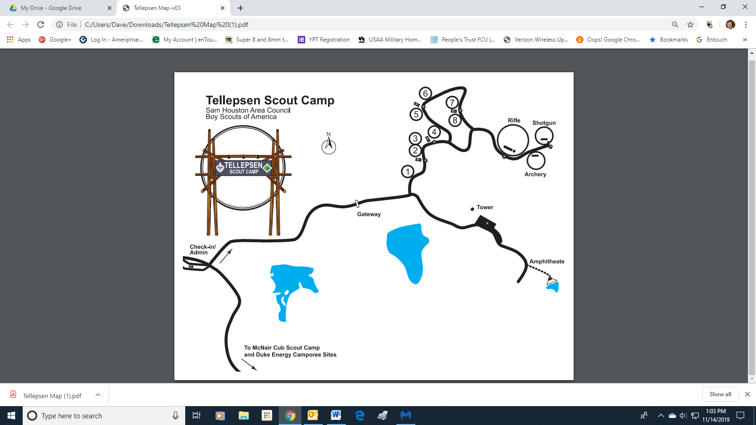

Hospital Location

